## **Analyze WireShark Captures:**

**Part 1:** Analyze TCP networking protocols.

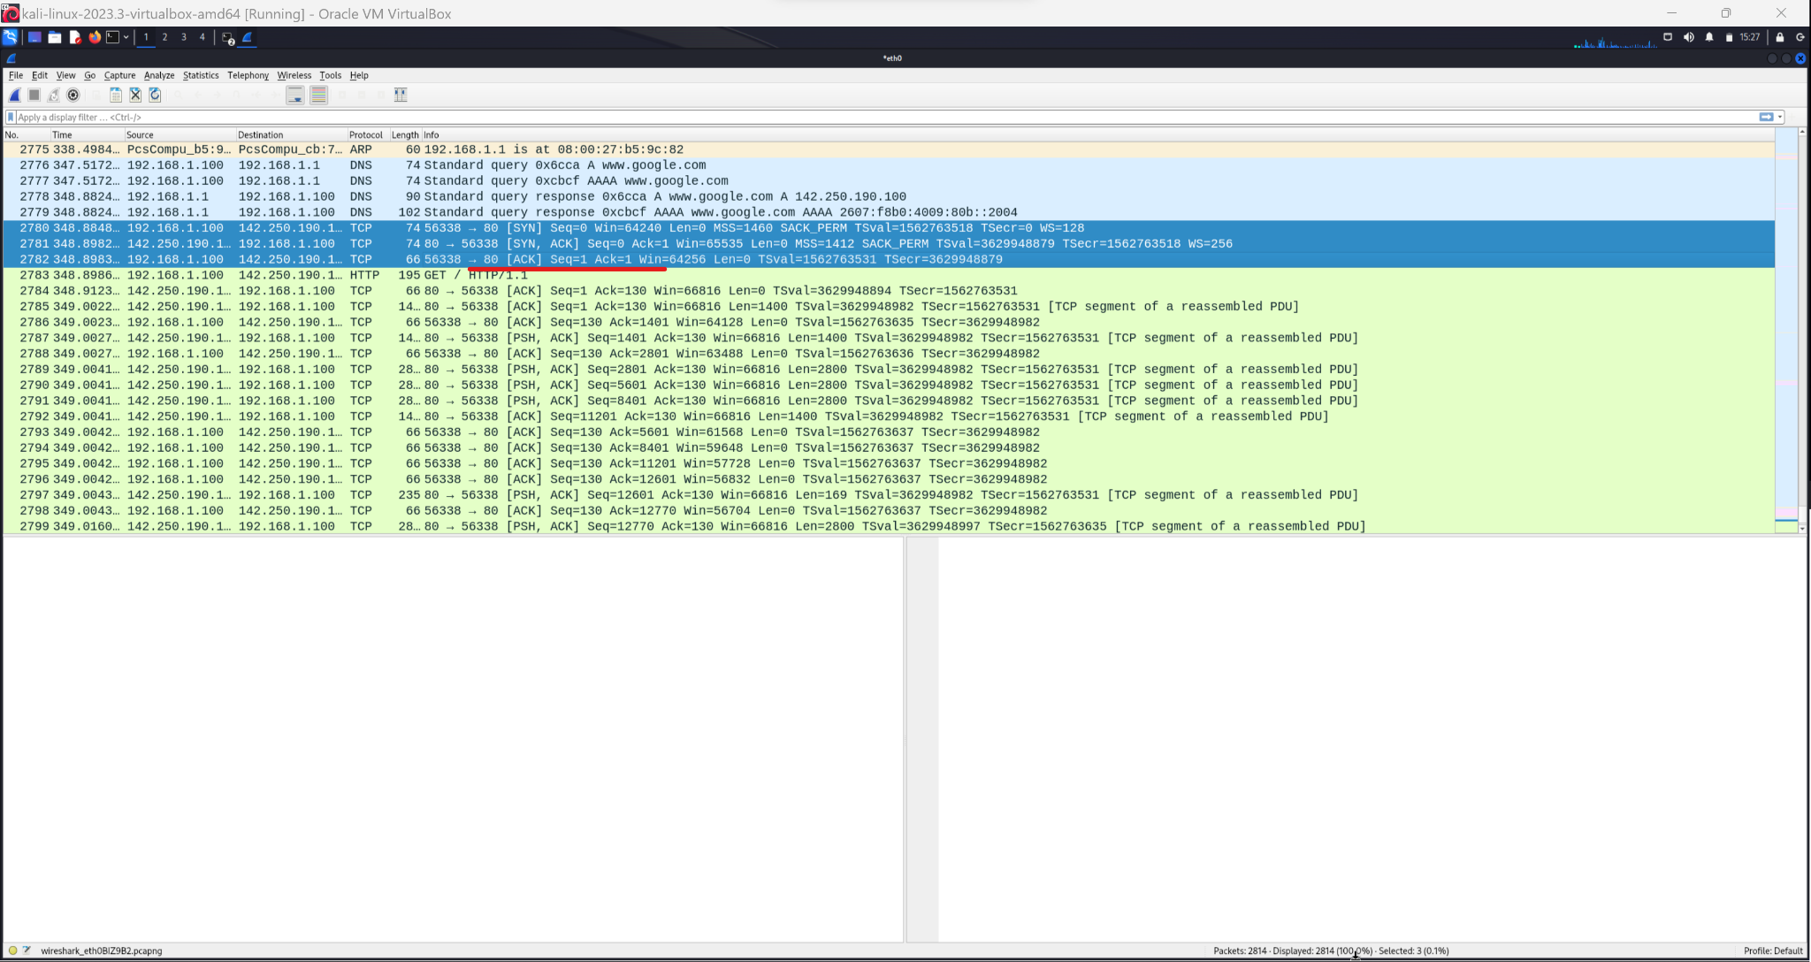

**Part 2:** Analyze UDP networking protocols.

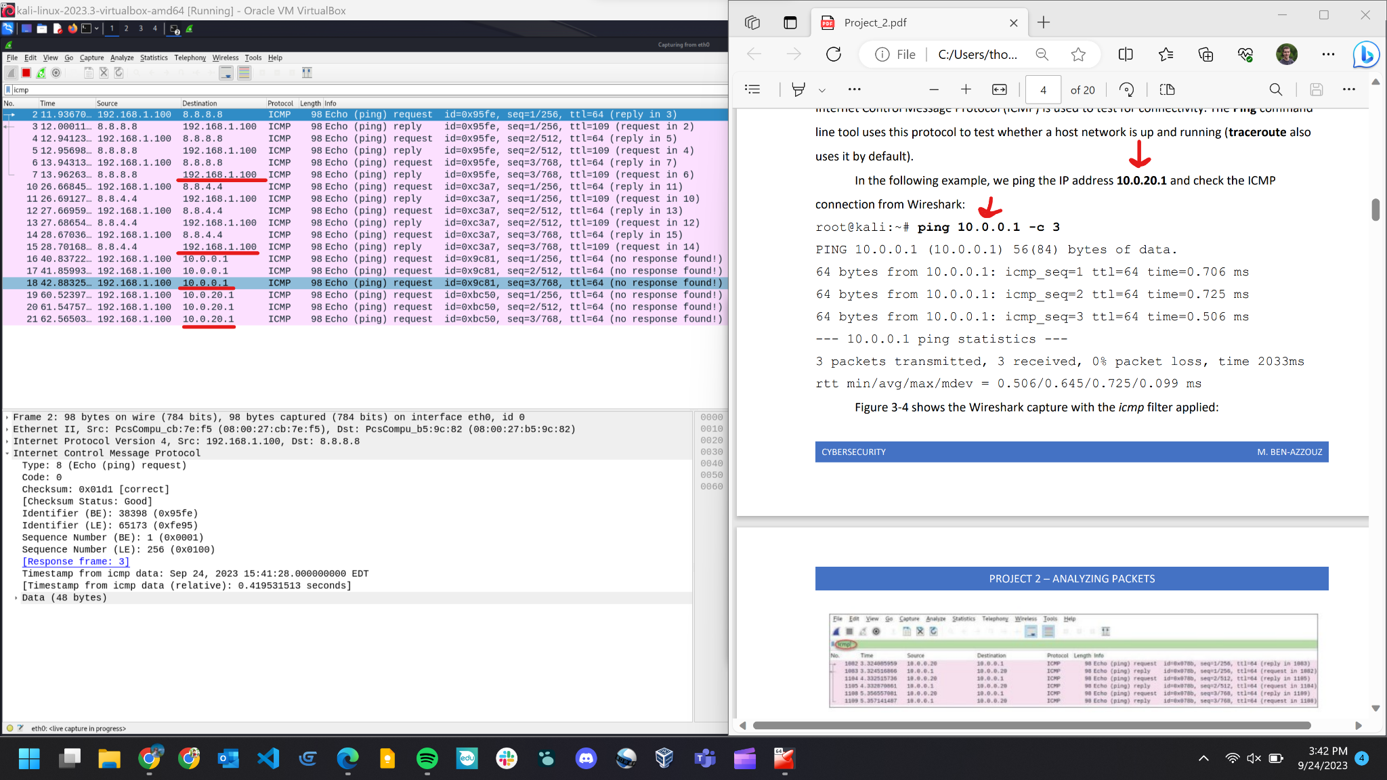

**Part 3:** Analyze ARP networking protocols.

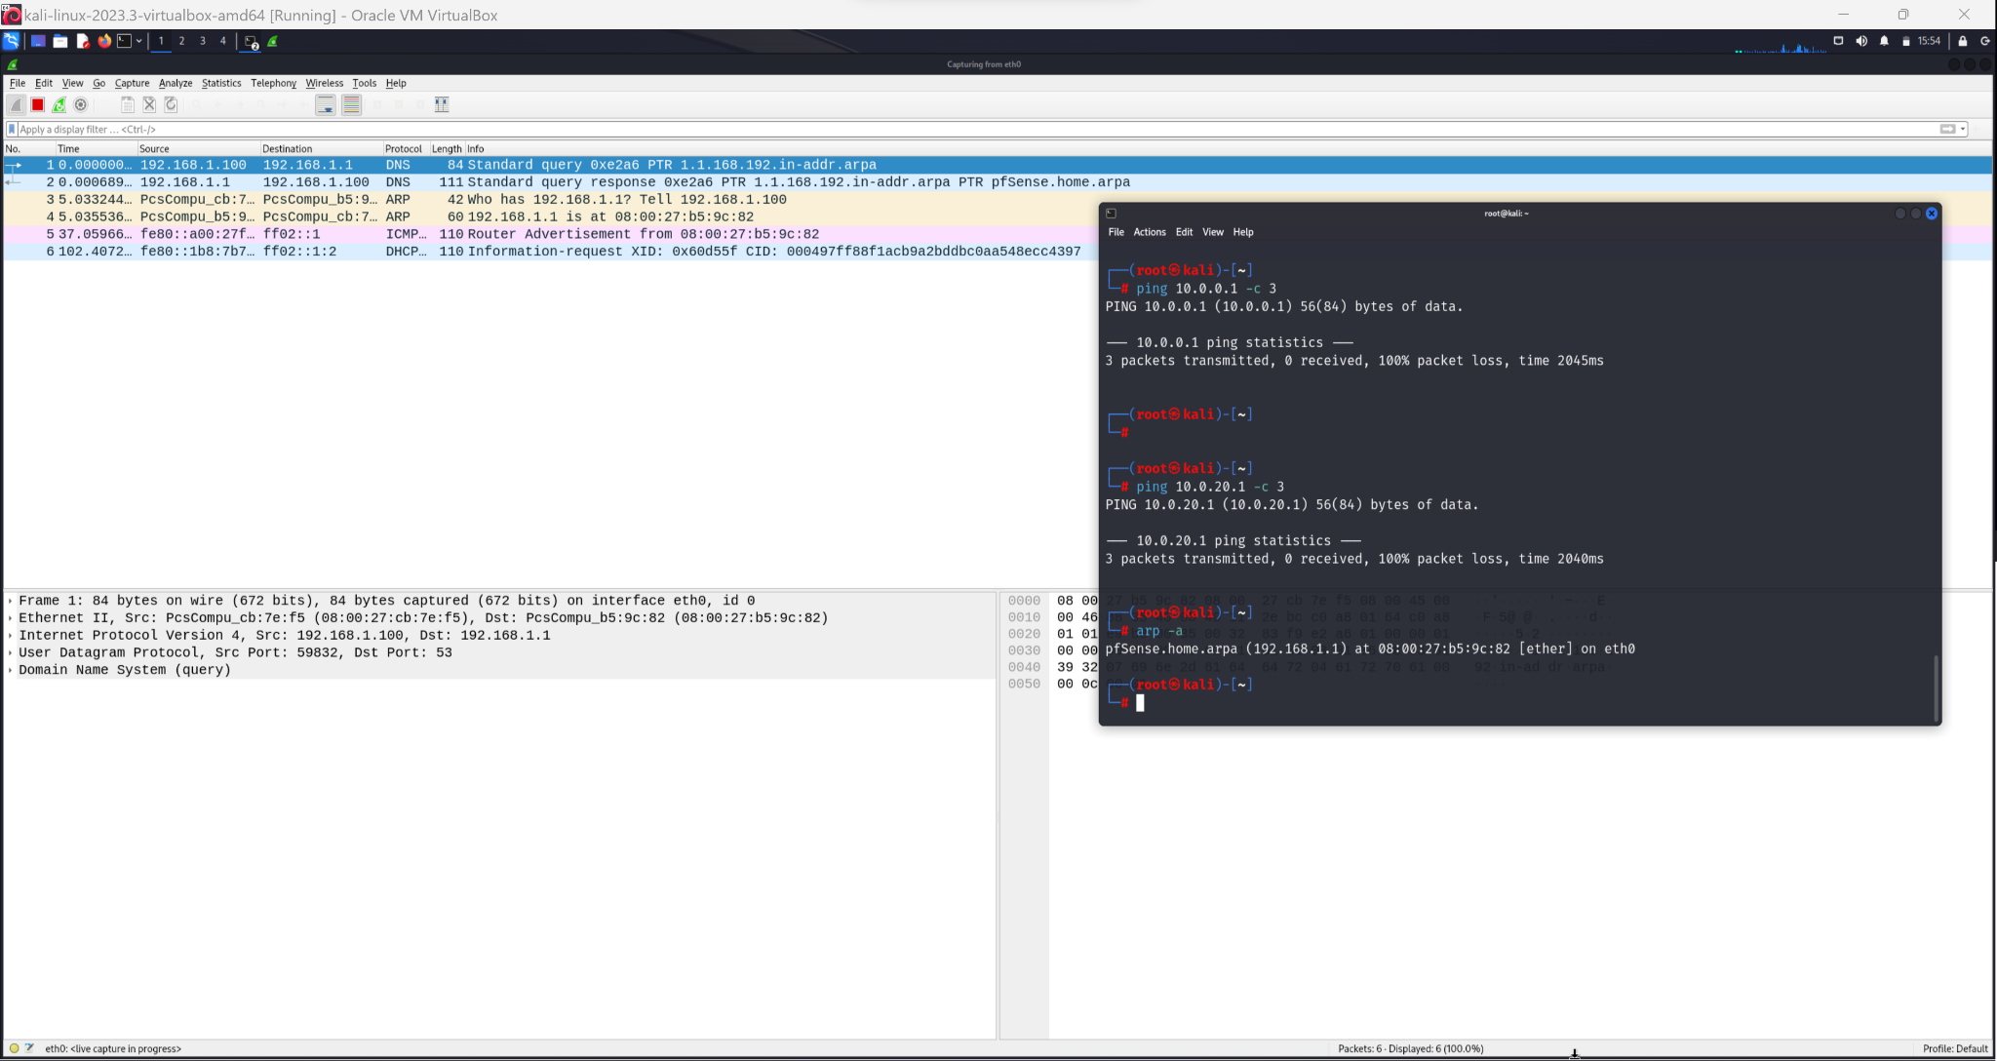

**Part 4:** Examine the reassembled TCP streams.

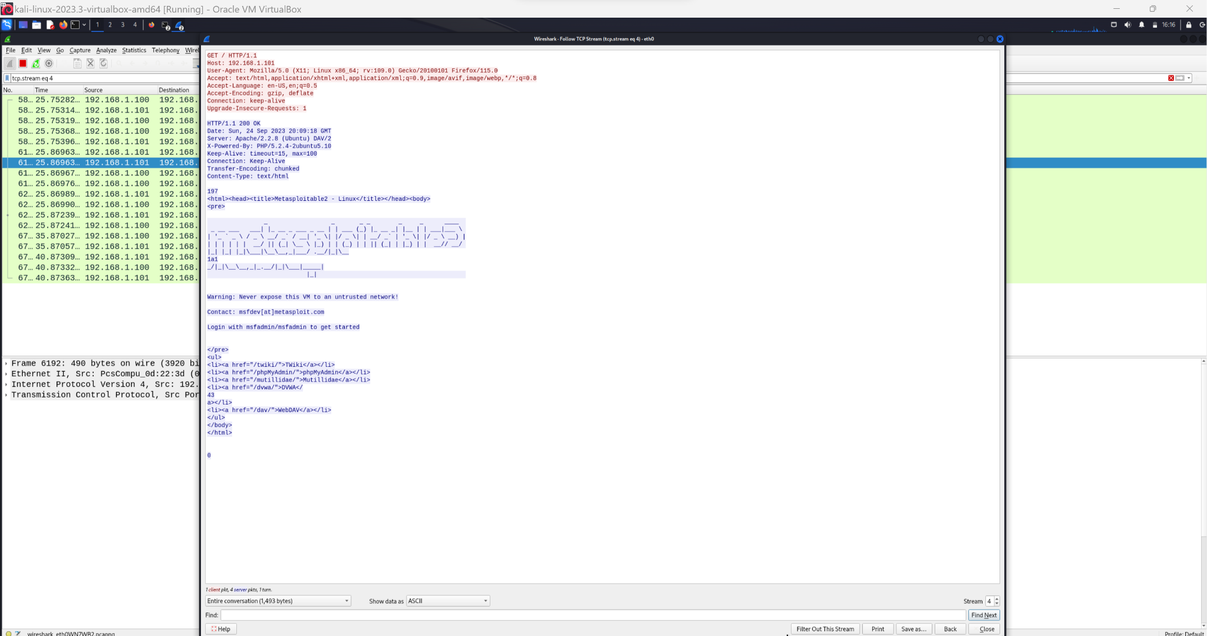

**Exercise 1:** Changed Password & Traffic Graphs

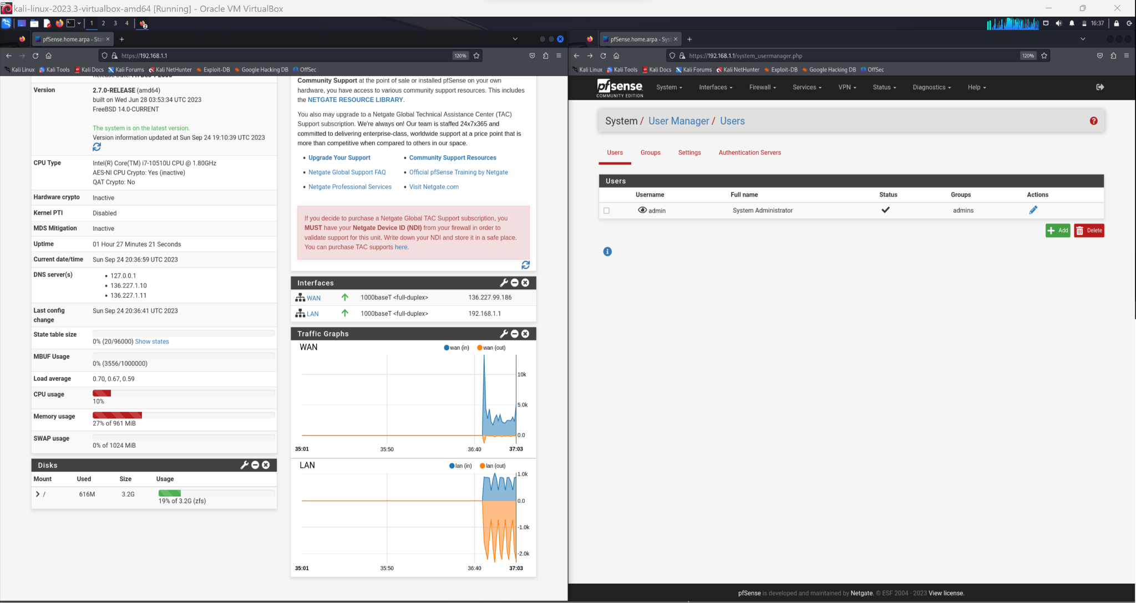

**Exercise 2:** Method for getting deliverables.

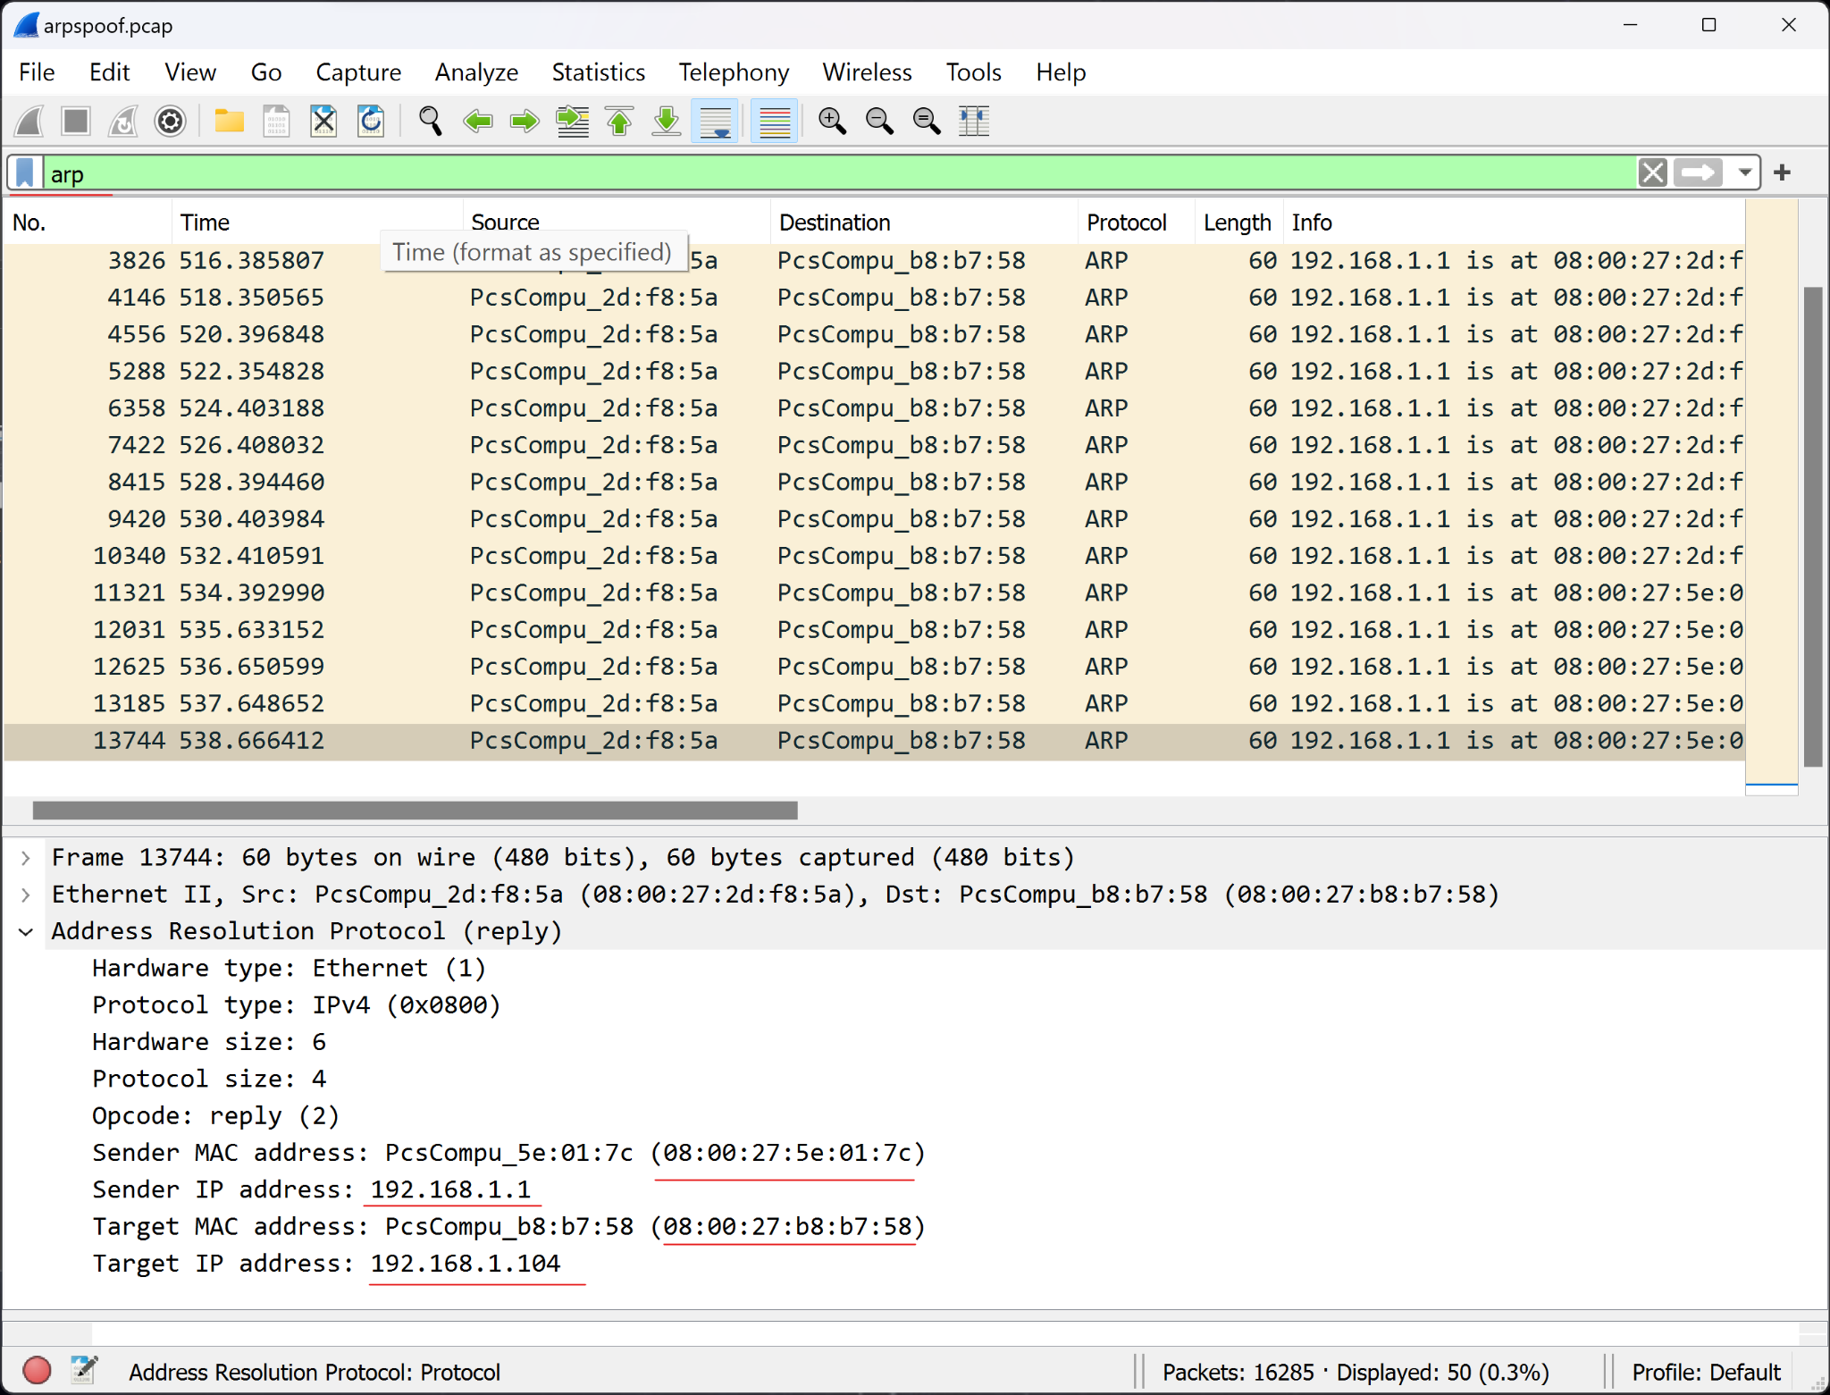

## Deliverables:

Victim: 192.168.1.105 08:00:27:b8:f8:5a

Attacker: 192.168.1.104 08:00:27:b8:b7:58

Router: 192.168.1.1 08:00:27:5e:01:7c